Over the course of the next couple of days we are going to work on several aspects of Ancient Greece. The idea is to work at a reasonable pace on various elements of what made Greece such an awesome civilization. You will need to use the following resources:
- Your text book
- A device (AKA laptop)
- Your brain – I know a lot to ask
We will take this assignment one day at a time. PLEASE DO NOT WORK AHEAD.
Day #1 –Choosing two God’s/Goddess 1._____________________2._____________________

- Aphrodite / Venus – goddess of love

- Apollo – god of the arts

- Ares / Mars – god of war

- Artemis / Diana – goddess of the hunt / protector of children

- Athena / Minerva - goddess of wisdom, war and crafts

- Cronus / Saturn - god of fertility and agriculture

- Demeter / Ceres – goddess of agriculture and fertility

- Dionysus / Bacchus – god of wine, mysteries and theatre

- Eros / Cupid – god of love and desire

- Gaia / Terra - Gaia was an Earth goddess; she is also the mother of the Titans

- Hephaestus / Vulcan – god of smiths and metal workers

- Hera / Juno – goddess of marriage

- Hermes / Mercury – god of merchants

- Hades / Pluto – god of the underworld; ruler of the dead

- Poseidon / Neptune – god of the sea and earthquakes

- Rhea / Ops – mother of Zeus, Hades, Poseidon and others
- Zeus / Jupiter – god of the sky

- Persephone – goddess of the underworld

- Heracles / Hercules - legendary for his strength and famous twelve labors

- Edipus / Oedipus - king of Thebes; his tragic story forms the basis for the Sophoclean trilogy (killed his father and married his mother)

- Antigone - daughter of Oedipus who sacrificed herself in the name of justice and honor

- Helen of Troy - provided the Greeks and Trojans with the excuse for the infamous Trojan war

- Pegasus - Pegasus was an immortal winged horse who played an exciting role in Greek myth

- Medusa - one of the Gorgons; Medusa is traditionally depicted as a dangerous snake haired woman

- Atlas - Atlas was a legendary Titan in Greek mythology; he held the heavens up.

- Hypnos / Somnus – god of sleep

- Hecate – goddess of magic

- Pan – god of the countryside (1/2 man, ½ goat)

- Pandora - the first woman, created by Zeus; her name means "all gifts"

- The Muses - The Muses were the daughters of Zeus and Mnemosyne (Memory). They presided over song, and prompted the memory. They were nine in number, to each of whom presided over a particular department of literature, art, or science.

- Odysseus - hero of the eponymous Odyssey, a great adventurer; king of Ithaca

- The Titans - The Titans were a race of gods who were the parents and precursors of the Olympians. They were defeated by this younger generation of deities, who were led by Zeus

- Narcissus - this is a myth about a man smitten by his own reflection

- Other _____________.

Now that you have chosen your god we need to spend some time getting to know what they’re all about. In the space provided for each topic fill each section (to receive full credit) with evidence. You will be graded on your depth and accuracy.

#1 God’s Origin and History
____________________________________________________________________________________________________________________________________________________________________________________________________________________________________________________________________________________________________________________________________________________________________________________________________________________________________________________________________________________
____________________________________________________________________________________________________________________________________________________________
Your Sources ____________________________________________________________________________________________________________________________________________________________
#1 God’s Special Story and Uniqueness
____________________________________________________________________________________________________________________________________________________________________________________________________________________________________________________________________________________________________________________________________________________________________________________________________________________________________________________________________________________
____________________________________________________________________________________________________________________________________________________________
Your Sources ____________________________________________________________________________________________________________________________________________________________

#2 God’s Origin and History
____________________________________________________________________________________________________________________________________________________________________________________________________________________________________________________________________________________________________________________________________________________________________________________________________________________________________________________________________________________
____________________________________________________________________________________________________________________________________________________________
Your Sources ____________________________________________________________________________________________________________________________________________________________
#2 God’s Special Story and Uniqueness
____________________________________________________________________________________________________________________________________________________________________________________________________________________________________________________________________________________________________________________________________________________________________________________________________________________________________________________________________________________
____________________________________________________________________________________________________________________________________________________________
Your Sources ____________________________________________________________________________________________________________________________________________________________

To finish day #1 Greek Mythology in advertising today
You will need to find three examples of where Greek Mythology is used in advertising today. I am going to use two that are really obvious and you are not allowed to use. Ha Ha The first is Mobile Gas and then Trident Gum.

Find Three Examples and draw them in the space provided below. Once you have completed your drawings explain what the connections are to ancient Greek history.

Day # 2 – Government and Society – Primary Sources
HOW CAN THE SOCIAL CLASSES OF ANCIENT GREECE DEFINE THE TIME PERIOD?
As you read these sources, remember to:  Circle words you do not understand.  Underline sections that are unclear.  Periodically make notations in the margin that summarizes what you have just read.
NOTES
DOCUMENT 1 Population of Athens
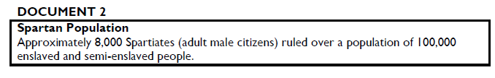
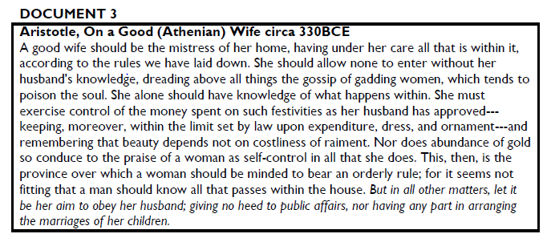
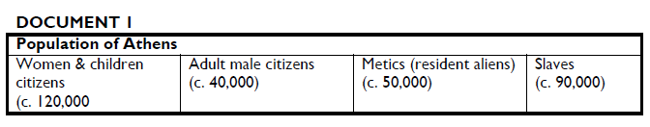

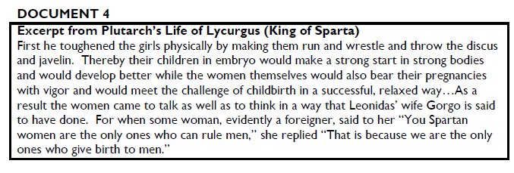

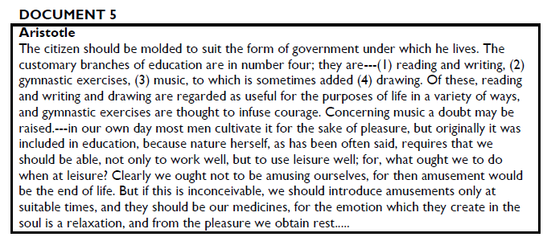
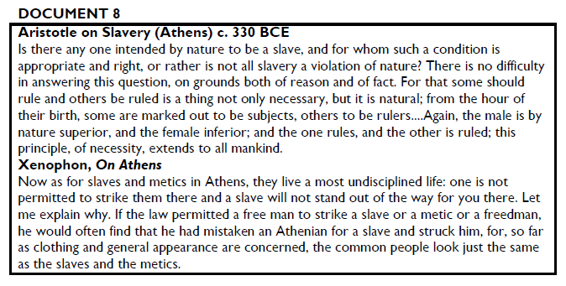
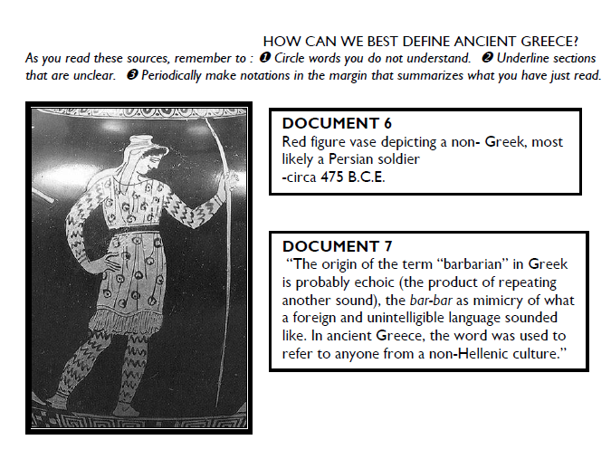
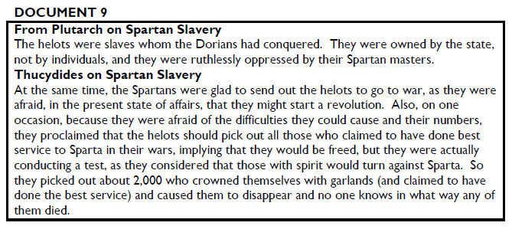
Using the Documents above now work to fill in the following document:
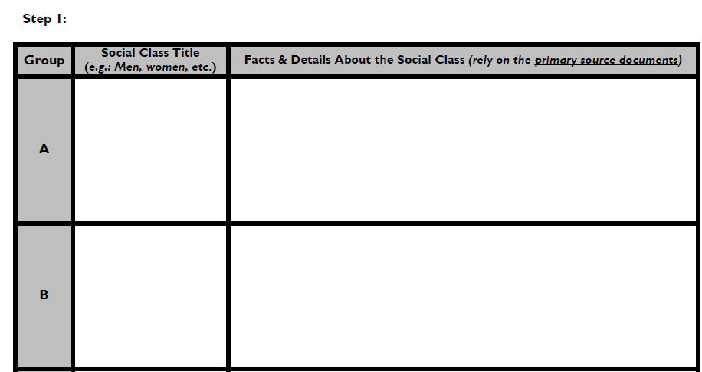
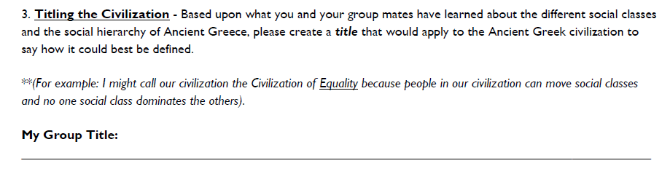
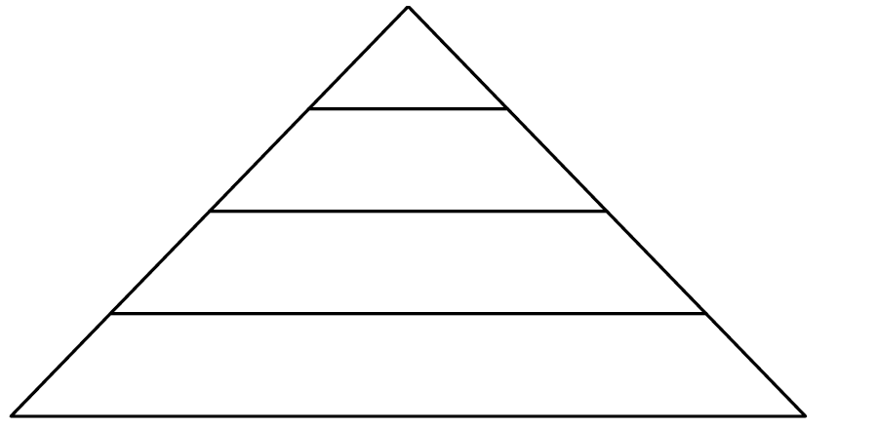
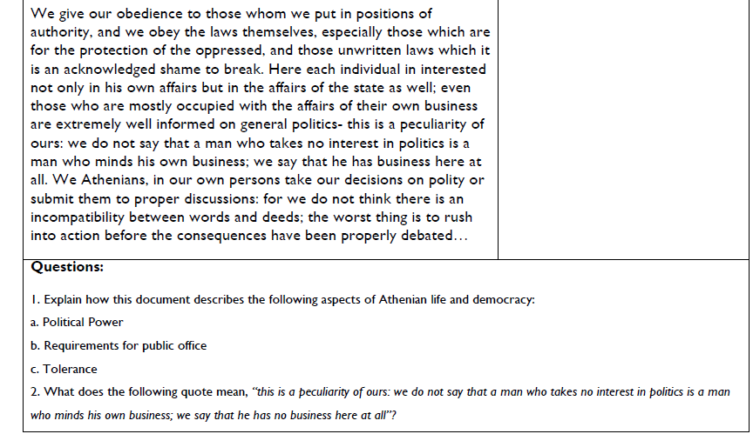
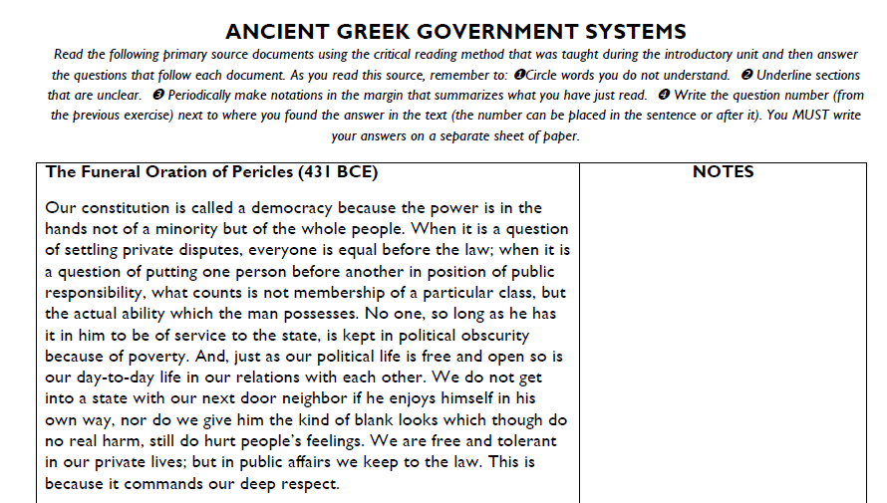
Day #3
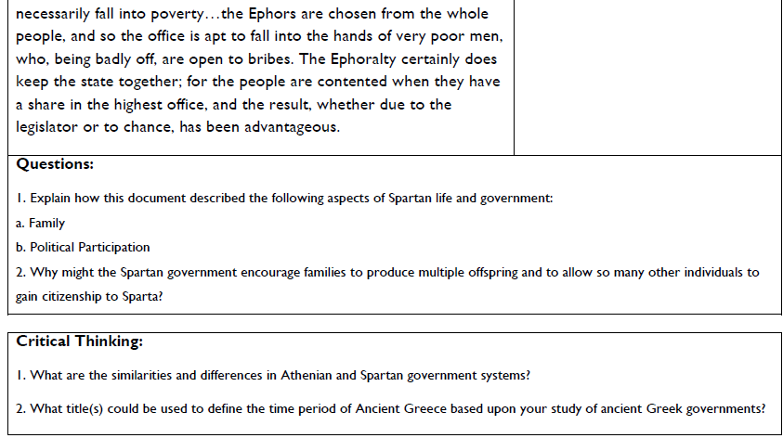
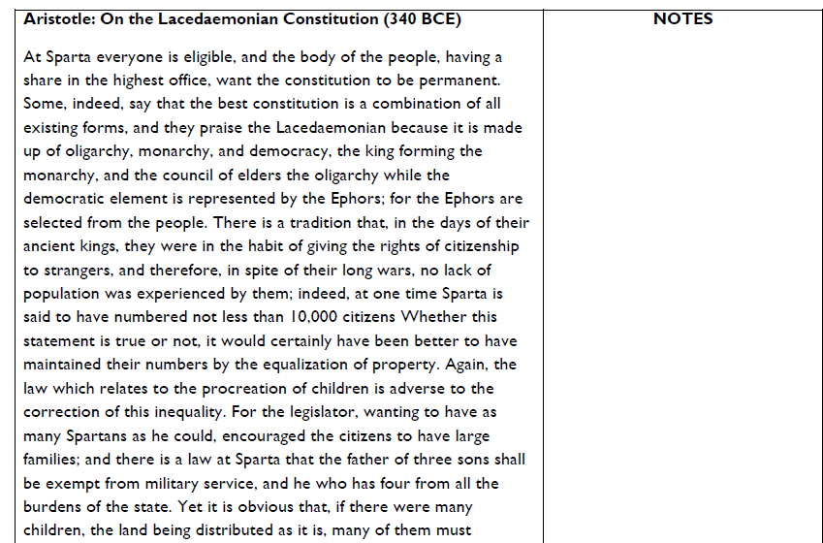
Architecture is one of the more important aspects of the impact of Ancient Greece. Please watch the video provided with the following link. This will help to comprehend the detail and impact the Greek Architecture has on our society today. (10 Min)
https://www.khanacademy.org/humanities/ap-art-history/ancient-mediterranean-ap/greece-etruria-rome/v/the-classical-orders
Now provide four examples of Greek architecture in American society today. Be sure to fill the entire space with evidence as to why this is an example of Greek architecture.
#1
____________________________________________________________________________________________________________________________________________________________________________________________________________________________________________________________________________________________________________________________________________________________________________________________________________________________________________________________________________________
#2 ____________________________________________________________________________________________________________________________________________________________________________________________________________________________________________________________________________________________________________________________________________________________________________________________________________________________________________________________________________________
#3
____________________________________________________________________________________________________________________________________________________________________________________________________________________________________________________________________________________________________________________________________________________________________________________________________________________________________________________________________________________

#4 ____________________________________________________________________________________________________________________________________________________________________________________________________________________________________________________________________________________________________________________________________________________________________________________________________________________________________________________________________________________

